1. **How will your Project benefit from React**
   1. *What are the main differences between Boostrap and React?*

* The main difference is an “Inversion of Control”. The **Boostrap** is a CSS framework with jQuery dependencies, which already defines a control flow and skeleton for a custom application. A predefined control flow and skeleton in Bootstrap framework dictates how the application (with its own features) will be rendered in window.
* **React** is open-source Javascript library, which contains collection of modules [*routings* (methods, such as setState(), constructor(), render(), ect.] for functional programming and *classes* for object-oriented programming]. The application flow and skeleton is in control of React libraries, which can be called at any time at any components.

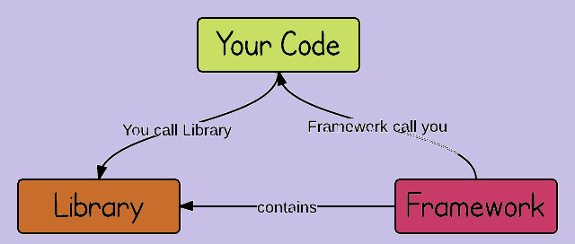

* 1. *What will React allow you to do that would have been difficult with Bootstrap?*

Due to its sizeable hard-coded jQuery dependencies and plug-ins, the Bootstap framework components are difficult to customize in order to meet custom requirements and necessities of application. Majority of of its built-in features (especially those with jQuery plugins) either not useful at all or not easy to modify and fit into a custom application.

The React libraries are less in size, but provide more *versatility, scalability, flexibility, creativity* in a front-end interface development because they don’t control, but support a flow and architecture of application. Additionally, to assist a developer, React its own rebuilt Bootstrap components called Reactstrap.

1. **Expected List of React Components**
   1. *A brief list of the React Components you will need to develop for your application*

* Navbar Component
* Carousel Component
* Jumbotron Component
* Media Component
* Tabs Component
* Modal Component
* Pagination Component
* Form Component

This list is open-ended because there is a possibility that more of them will be added to add more features

* 1. *Brief justification for including these components*

All Reactstrap components listed above will be reusable in our Visit Georgia application, which will contain Home, Activities, Tours page.

1. **Team Responsibilities**
   1. *Which team member will own development of which React Component?*

Since James is still deciding which team he will join, we will split the React Components between Sergey and Geneva. If James decides to join our team, we will redistribute the responsibilities with the possibility of adding more Components.

Sergey- Carousel Component, Tabs Component, Modal Component, Pagination Component

Geneva-Navbar Component, Jumbotron Component, Media Component, Form Component